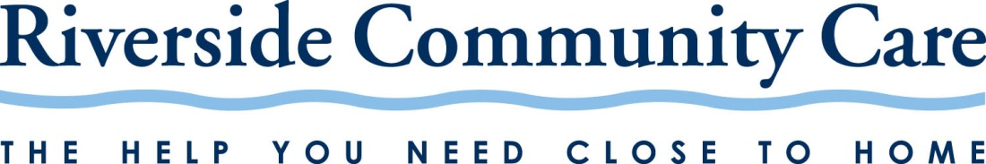

Riverside Community Care’s

Self-Determination/Recovery/Resiliency/Wellness Statement

Riverside Community Care is committed to working in partnership with the people we serve to support each individual’s journey of Self-Determination/Recovery/Resiliency/Wellness within and beyond the organization.

Riverside believes:

- Self-Determination/Recovery/Resiliency/Wellness is a process by which a person who experiences an illness or disability builds a life defined by strengths, physical and emotional well being, and community membership.
- Our services must be provided from a perspective of hope and the belief that Self-Determination/Recovery/Resiliency/Wellness is possible for every person.
- Everyone within the Riverside community should be treated with dignity and respect.
- People receiving services have both rights and responsibilities for their own
Self-Determination/Recovery/Resiliency/Wellness.
- We must ensure that policy and practice are informed by the experiences, ideas and skills of people receiving services.
- We are all strengthened by the involvement of people in the process of
Self-Determination/Recovery/Resiliency/Wellness in every aspect of the organization - as directors, employees, committee members, advocates, mentors, peer supporters and other valued roles.
- We are committed to providing services in a person/family-centered manner. We must work in collaboration with the adults, youth and families receiving services to support their own goals and preferences, as well as their success in work, school, parenting, or other meaningful social roles.
- We must utilize a strength-based and culturally competent approach in all of our practices.
- We strive to eliminate barriers to Self-Determination/Recovery/Resiliency/Wellness within the healthcare and social service system.

